SKIN CANCER PATIENT ANALYSIS TABLE
Patient 1 Information  The patient is a 73-yr.-old Caucasian male with fair skin who has had 3 melanomas removed in the past 2 years. He is a self-confessed beach bum since his youth. The mole is located on his right shoulder and is 7 mm in diameter | 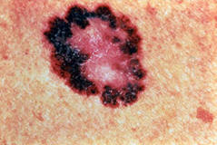 | 1. Is there a possibility the mole is cancerous and why/why not?  2. What is your advice to the patient for this mole? (none, proper sun care, removal, etc.)
Patient 2 Information  The patient is a 69-yr.-old Caucasian female with fair skin. She has recently moved to the U.S. and this is the first time she has had this mole examined. It has been developing since she was in her late teens. It is located on her left cheek and is 23 mm in diameter. | 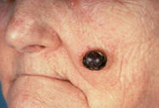 | 1. Is there a possibility the mole is cancerous and why/why not?  2. What is your advice to the patient for this mole? (none, proper sun care, removal, etc.)
Patient 3 Information  The patient is a 34-yr.-old Hispanic male. He has lived in Brazil for most of his life, and moved to the U.S. last year. He would like the mole looked at since it was previously much smaller, and appears to be increasing in size. It is 3 mm in diameter and is located on the dorsal surface of the foot. | 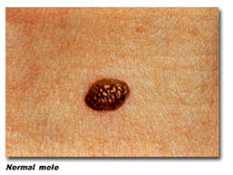 | 1. Is there a possibility the mole is cancerous and why/why not?  2. What is your advice to the patient for this mole? (none, proper sun care, removal, etc.)

