Histology Quiz
Question 1
Identify this tissue: | 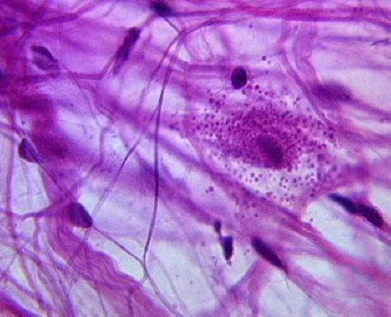
Identify the thin strands:
Identify the thick strands:
Identify the small dark purple structures:
Identify the large granular-looking cell:

Question 2
Identify this tissue: | 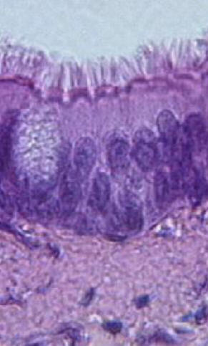
Identify light grey region at the top of the image:
Identify the oval granular structure on the left side of the image:
Identify one major function of this specific type of tissue

Question 3
Identify this tissue: | 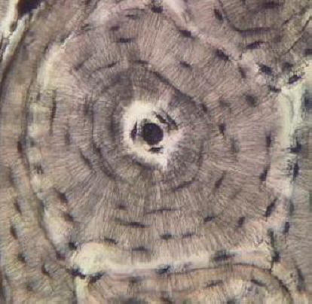
Identify the dark circular structure at the center:
Identify the series of ring-like layers surrounding the center:
Identify the fine meshwork of structures seen throughout:

Question 4
Identify this tissue (Hint: image shows a surface view): | 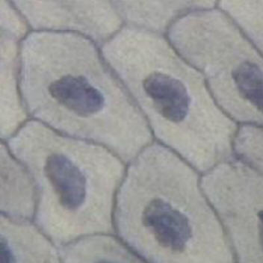
Identify the dark round structures:
Identify a location where this tissue is found:

Question 5
Identify this tissue (Hint: it's not muscle): | 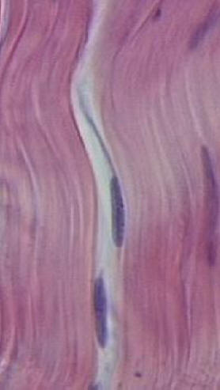
What type of cell produces this tissue:
Identify the elongated purple structures:
Identify a location where this tissue is found:

Question 6
Identify the purple layer of tissue just above the pink region at the bottom of the image: | 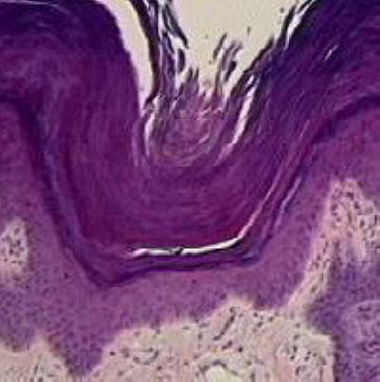
What is the thick purple debris above this tissue:
Identify a location where this tissue is found:

Question 7
Identify this tissue: | 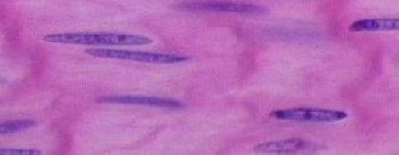
Identify several locations where this tissue found:

Question 8
Identify this tissue: | 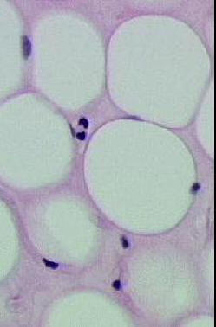
Identify the specific cell type shown here:
Identify the round white structures:
Identify the small dark purple structures:

Question 9
Identify this tissue: | 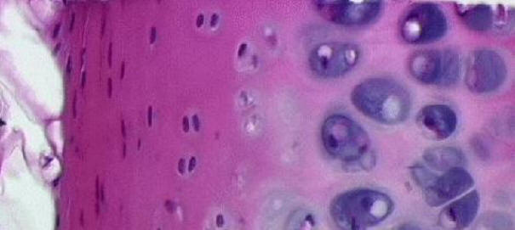
Identify the large blue cells to the right:
Identify the dark blue regions around the cells:
Identify the light opaque regions between the cells:
Identify the dark fibrous region to the left:
Question 10
Identify this tissue: | 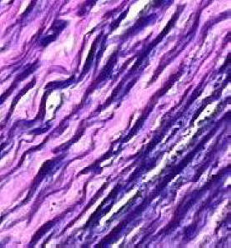
Identify the thick strands:
Identify the function of this tissue:

Question 11
Identify this tissue: | 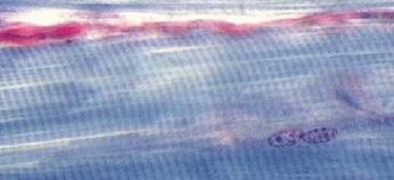
Identify the small dark purple structures:
Identify the patterns of light and dark bands:

Question 12
Identify this tissue (be specific): | 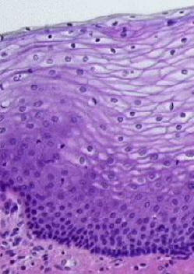
Identify a location where this tissue is found:
Identify the region of closely-packed cells near the bottom:

Question 13
Identify this tissue: | 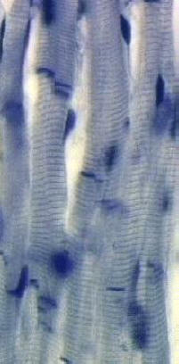
Identify the darkest lines here:
Identify the unique "electrical" connections in this tissue:
Identify a location for this tissue:

Question 14
Identify this large cell: | 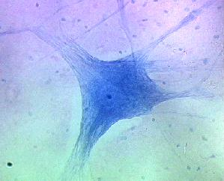
Identify the large processes extending from the cell:
Identify the tiny (specks) surrounding the large cell:
What is the function of these tiny peripheral structures:

