CELL STRUCTURE QUESTIONS
1) Is the cell in this electron micrograph to the right prokaryotic or eukaryotic? | 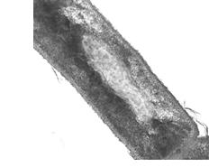

2) What structural differences did you observe between prokaryotic and eukaryotic cells?

3) Observe the electron micrograph below
a) Is the cell prokaryotic or eukaryotic?
b) Identify the labeled structures. (A, B, C)

A____________________
B____________________
C____________________

